**SQL PROJECT**

**STUDENT MANAGEMENT DATABASE**

**Project Objective:**This SQL project aims to create a Student Management System that provides essential insights into student data for educational institutions. Using SQL, this project aims to extract meaningful insights from various data points, enabling stakeholders to make informed decisions regarding student performance, enrolment trends, and resource allocation.

**Tools**

* MYSQL

**SCHEMA**

The Star Schema is Designed to create a Relationship Between the Tables to Ensure Integrity and Facilitate Complex

**Schema**

Student_Management_Database

**Table Name Table Name Table Name**

Enrollments

Students

Courses

**Columns Column Column**

**Student_id Course_id enrollment_id**

**First_name course_name student_id**

**Last_name Credits course_id**

**Date_of_birth enrollment_date**

**PRIMARY KEY Grade**

**FOREIGN KEY**

**Let’s dive into SQL to create the database and table as shown in the above schema**

**Need to follow the steps:**

* **Create the Database**
* **Create the Table with Appropriate columns and constraints**
* **Insert demo data for the Students, Course, and Enrolments Tables.**

**Below is a step-by-step SQL Script to create database and table**

**1. **Create the Database**:**

**\*/**

**CREATE DATABASE student_Management_Database;**

**USE student_Management_Database;**

**2** Create the Table**

**2. **Create the Tables**:**

**-- Table for storing student information**

**CREATE TABLE Students (**

**student_id INT PRIMARY KEY,**

**first_name VARCHAR(50),**

**last_name VARCHAR(50),**

**date_of_birth DATE,**

**gender CHAR(1)**

**);**

**-- Table for storing course information**

**CREATE TABLE Courses (**

**course_id INT PRIMARY KEY,**

**course_name VARCHAR(100),**

**credits INT**

**);**

**-- Table for storing enrollment information**

**CREATE TABLE Enrollments (**

**enrollment_id INT PRIMARY KEY,**

**student_id INT,**

**course_id INT,**

**enrollment_date DATE,**

**grade CHAR(1),**

**FOREIGN KEY (student_id) REFERENCES Students(student_id),**

**FOREIGN KEY (course_id) REFERENCES Courses(course_id)**

**);**

**Insert the data into the tables**

**INSERT INTO Students (student_id, first_name, last_name, date_of_birth, gender) VALUES**

**(1, 'John', 'Doe', '2000-01-15', 'M'),**

**(2, 'Jane', 'Smith', '1999-03-22', 'F'),**

**(3, 'Mike', 'Johnson', '2001-07-30', 'M'),**

**(4, 'Emily', 'Davis', '2002-10-05', 'F');**

**-- 2. **Insert Data into Courses Table**:**

**INSERT INTO Courses (course_id, course_name, credits) VALUES**

**(1, 'Mathematics', 3),**

**(2, 'English', 4),**

**(3, 'Computer Science', 3),**

**(4, 'History', 3);**

**-- 3. **Insert Data into Enrollments Table**:**

**INSERT INTO Enrollments (enrollment_id, student_id, course_id, enrollment_date, grade) VALUES**

**(1, 1, 1, '2023-01-15', 'A'),**

**(2, 2, 2, '2023-01-16', 'B'),**

**(3, 1, 3, '2023-01-17', 'A'),**

**(4, 3, 1, '2023-01-18', 'C'),**

**(5, 4, 4, '2023-01-19', 'B');**

**Now, we have inserted the data into all the tables and will retrieve the data using the queries.**

**1. Write the SQL Queries to find the Names of Students Enrolled in a Specific Course.**

**SELECT Students.first_name, Students.last_name**

**FROM Students**

**JOIN Enrollments ON Students.student_id = Enrollments.student_id**

**WHERE Enrollments.course_id = 1;**

**Output:**

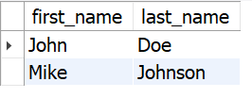

**2. Get the List of Courses a Specific Student is Enrolled In student id.**

**SELECT Courses.course_name**

**FROM Courses**

**JOIN Enrollments ON Courses.course_id = Enrollments.course_id**

**WHERE Enrollments.student_id = 1;**

**OUTPUT:**

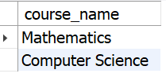

**3. Write the SQL Query to Retrieve the Average Grade of a Specific Course.**

**SELECT Courses.course_name, ROUND(AVG(CASE**

**WHEN grade = 'A' THEN 4.0**

**WHEN grade = 'B' THEN 3.0**

**WHEN grade = 'C' THEN 2.0**

**WHEN grade = 'D' THEN 1.0**

**ELSE 0.0**

**END),1) AS average_grade**

**FROM Courses**

**JOIN Enrollments ON Courses.course_id = Enrollments.course_id**

**WHERE Courses.course_id = 1**

**GROUP BY Courses.course_name;**

**OUTPUT:**

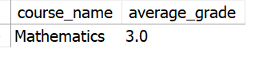

**4. List All Students with Their Enrolled Courses.**

**SELECT Students.first_name, Students.last_name, Courses.course_name**

**FROM Students**

**JOIN Enrollments ON Students.student_id = Enrollments.student_id**

**JOIN Courses ON Courses.course_id = Enrollments.course_id**

**ORDER BY Students.last_name, Students.first_name;**

**OUTPUT:**

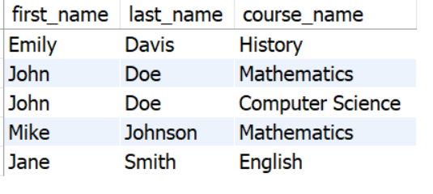

**5. Write an SQL Query to retrieve the Total Number of Enrollments Per Student.**

**SELECT Students.first_name, Students.last_name` COUNT(Enrollments.enrollment_id) AS total_enrollments**

**FROM Students**

**LEFT JOIN Enrollments ON Students.student_id = Enrollments.student_id**

**GROUP BY Students.student_id, Students.first_name, Students.last_name;**

**OUTPUT:**

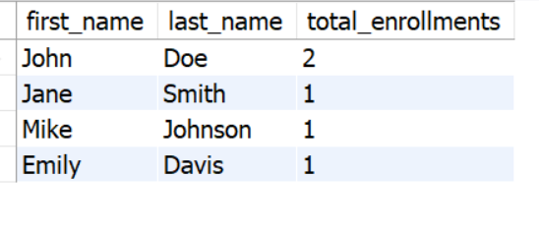

**7. Write a SQL query to Find the Highest Grade for Each Course.**

**SELECT Courses.course_name, MAX(Enrollments.grade) AS highest_grade**

**FROM Courses**

**JOIN Enrollments ON Courses.course_id = Enrollments.course_id**

**GROUP BY Courses.course_name**

**ORDER BY highest_grade;**

**OUTPUT:**

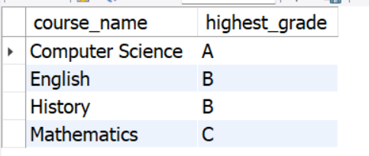

**8.. Write a SQL Query to Get Enrolment Details for Students Born After a Specific Date.**

**SELECT Students.first_name, Students.last_name, Enrollments.enrollment_date, Courses.course_name**

**FROM Students**

**JOIN Enrollments ON Students.student_id = Enrollments.student_id**

**JOIN Courses ON Enrollments.course_id = Courses.course_id**

**WHERE Students.date_of_birth > '2000-01-01';**

**OUTPUT:**

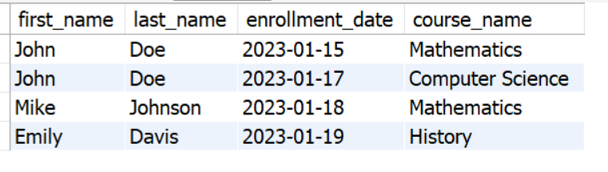

**Export the findings as a CSV file and create a visualization with Tableau, Power BI, and other visualization tools.**

**Thank You**

**.**